Script | Slide
Good morning. Today I’ll cover the topic on the “Evolution of Technology and the Impact on Consumers”. | 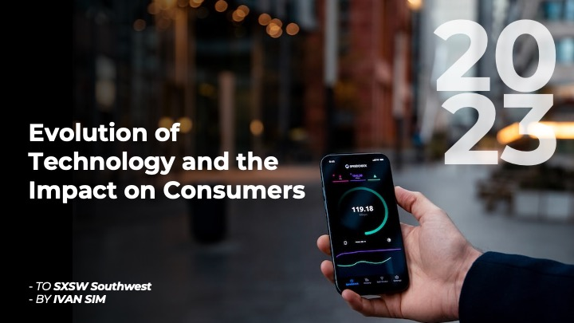
Based on the Timeline that I researched, technology has advance so fast within 80 years. From the first radio invented in 1941 to the invention of crypto currency in 2023. And currently we are in the AI (Artificial Inteligience phase). | 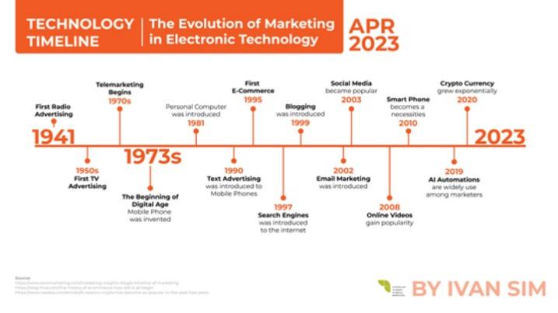
In the next two slides, shows the advantages and disadvantages of technological advancement. On one hand, technology enhances people’s lives by improving aspects like transportation. On the other hand, it can be exploited by criminals for their own purposes. | 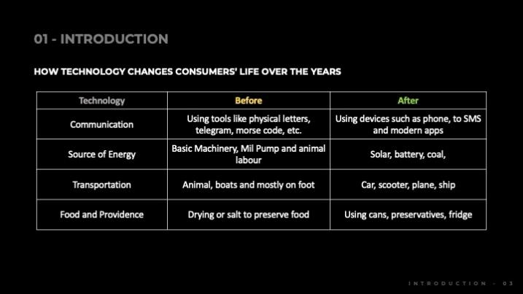  
One major advancement in technology is the introduction of the internet. Today, the internet has been intergrated to our daily lives.  窗体顶端  窗体底端  窗体顶端  窗体底端 | 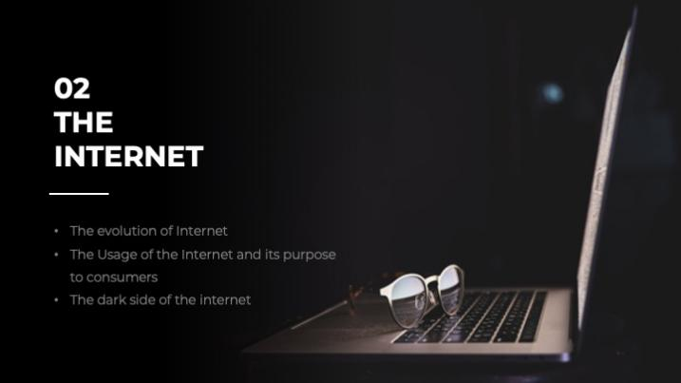
The internet works in a way where we are able to connect with each other almost effortlessly through technological devices. We can see briefly from this chart how the internet works, and the ISP’s that enable us to connect to it. | 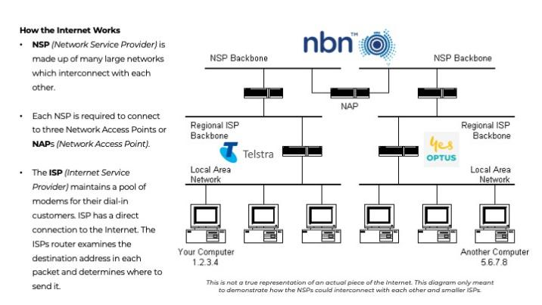
This chart shows the top uses for the internet include Finding Information, Keeping in Touch with loved ones and staying up to date with news and media, among many others. | 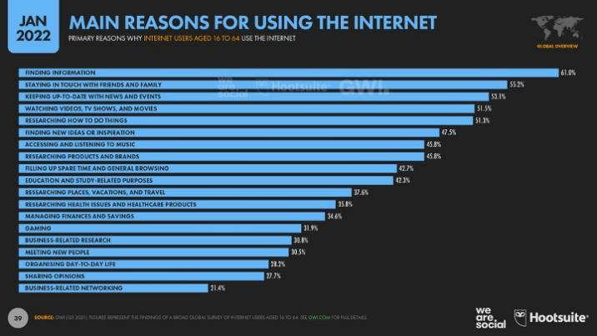
The disadvantages of the internet is the rise of cybercrimes.  Based on the graph shown, investment frauds and scam being the leaders in this. | 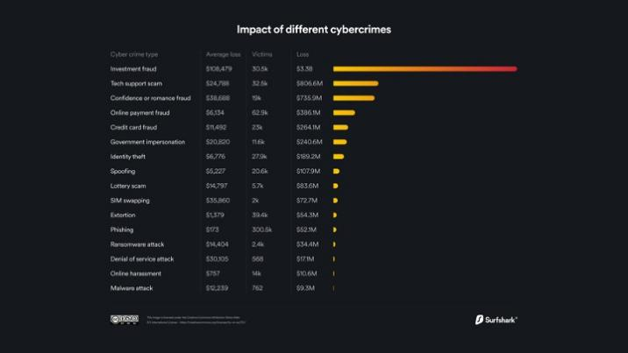
It's become a big issue with law enforcements and governments pouring more and more expenses each year into combating these cybercrimes. | 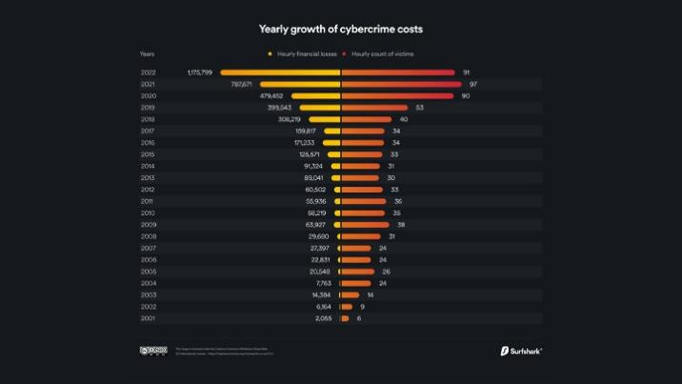
The internet wouldn’t be what it is today without the Digital Devices that enable it. | 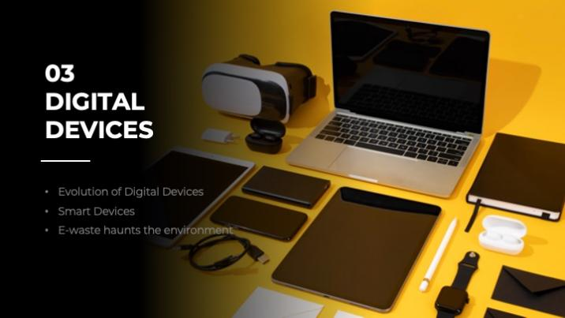
Devices are so deeply rooted in our lives now, even down to our homes being integrated with tech and smart devices, enabling more convenience in day-to-day living. | 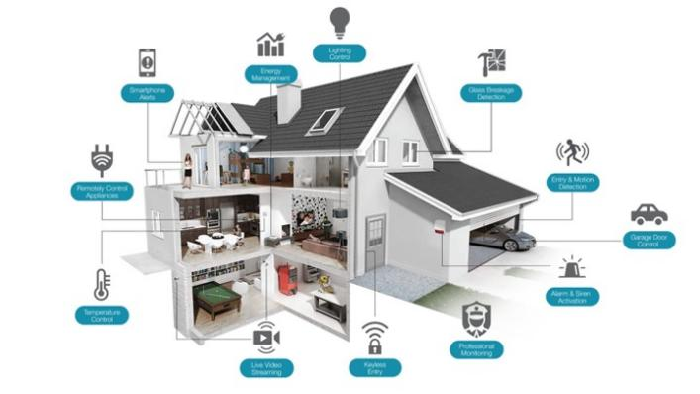
The percentage of ownership increases for multiple device categories with smartphones and computers leading the charge. | 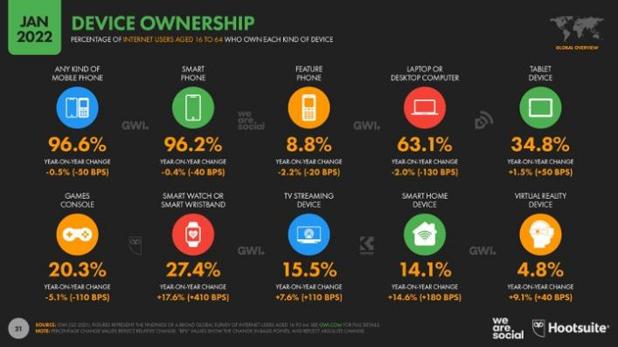
Yet with these astronomical increases in device manufacturing and ownership comes a new issue, E-Waste.  Rapid advancements and improvements in tech brings the need for the latest and greatest device, yielding about 53 Million tonnes of E-Waste being dumped from obsolete or unwanted devices. | 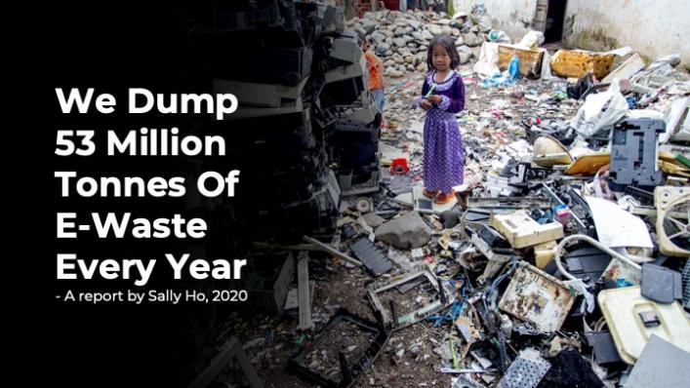
Technology has evolved the way consumers search for information. For an example, previously consumers used to search for a business through a book called Yellow pages. And now, any information is just a click away. | 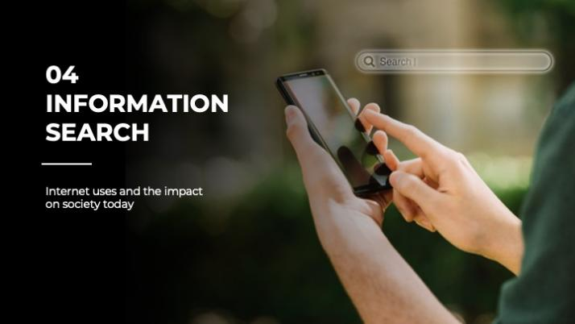
One of the key aspect of enhancing information search is to be able to observe consumer behaviors plays into these search engines.  We can see how search engines impact how a consumer makes a decision, and in turn the consumer’s search helps push products, websites and brands forward up the search engine ladder. | 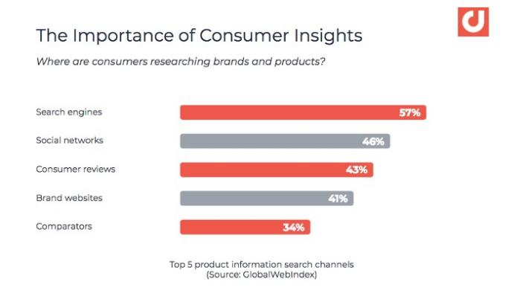
The internet is not all sunshine and online-shopping-sprees however.  The web goes much deeper than the surface level most of us are fond of and know about.  The Deep Web and Dark Web exist outside of traditional search engines and browsers and many illegal and degenerate content resides there that I won’t get into. | 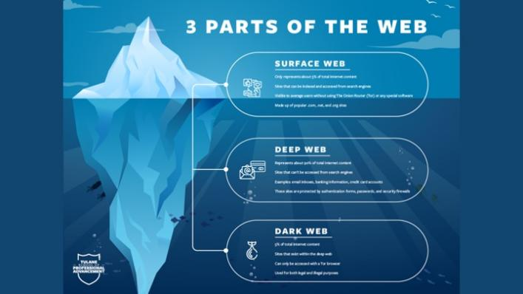
I think I am not the only one to say this, but I love online shopping. It’s one of the biggest impact on consumer purchasing behavior.  Online shopping has roots in 1979 when Michael Aldrich showcased one of the first online shopping systems. | 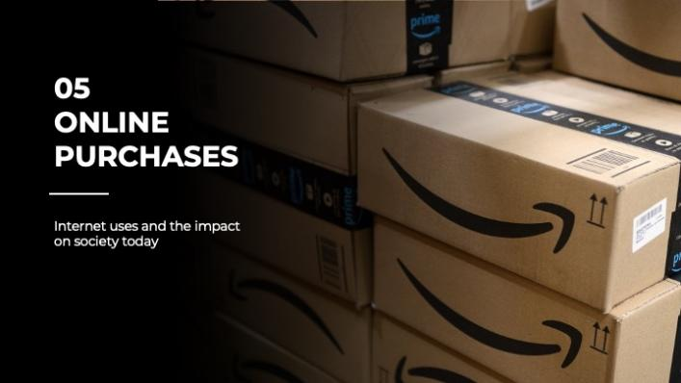  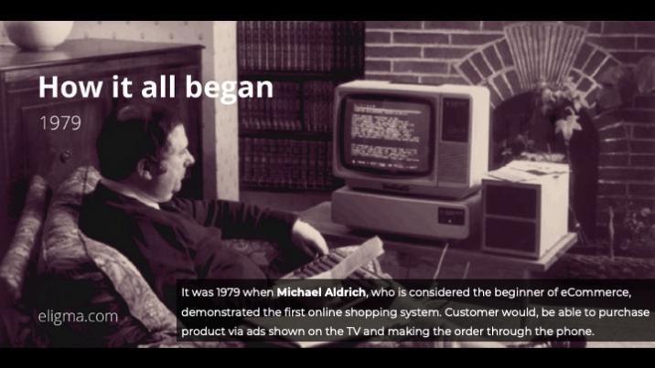
Cheaper deals and just about anything can be found from the palm of your hand at any time or place now thanks to online shopping.  The downsides are that we can’t see and item in person, and counterfeit items are harder to gauge with no one to guide us.  It also takes a while for items to be delivered when we could just leave a store with what we need. | 
Do you spend a lot of time looking through the reels in your social media platform or videos in Youtube? With advanced technological devices, both consumers and businesses can benefit from video. | 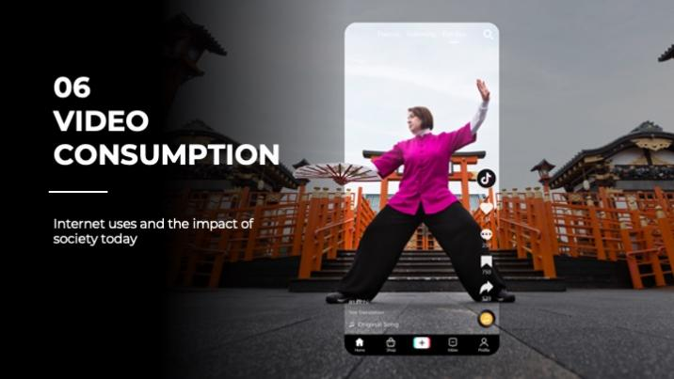
And this graph shows us how much we are spending our time on video consumption | 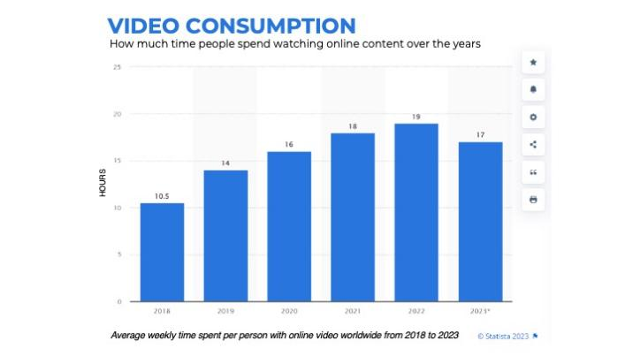
Video is also widely used as a tool for marketing, and in recent years the adoption of it by companies has rose, but we can start to see some levels of saturation as of recent years. | 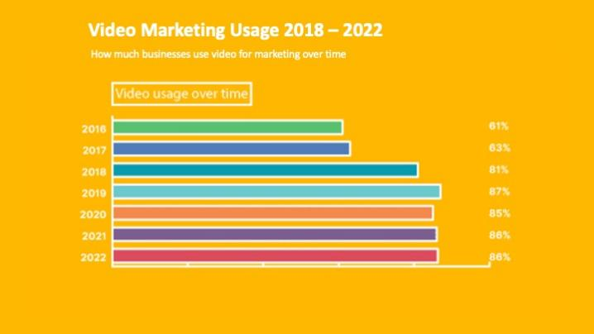
Videos are widely used and produced daily, with social media and streaming making it easier to consume.  But over saturation of content and marketing are a problem and viewers are starting to grow weary of the potential downsides which include addiction, overworking artists and creators and even invasion of privacy. | 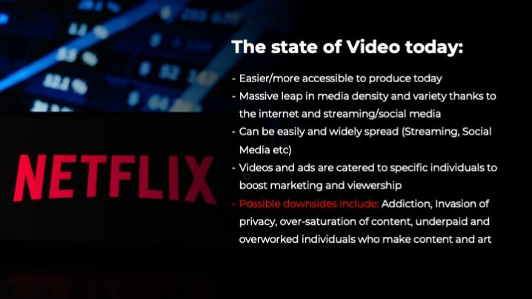
With the internet connecting everyone from everywhere, cultures and trends don’t just evolve locally but world wide. | 
Technology is Convenience.  It allow us to do many things that makes our lives easier like remote working and online shopping. | 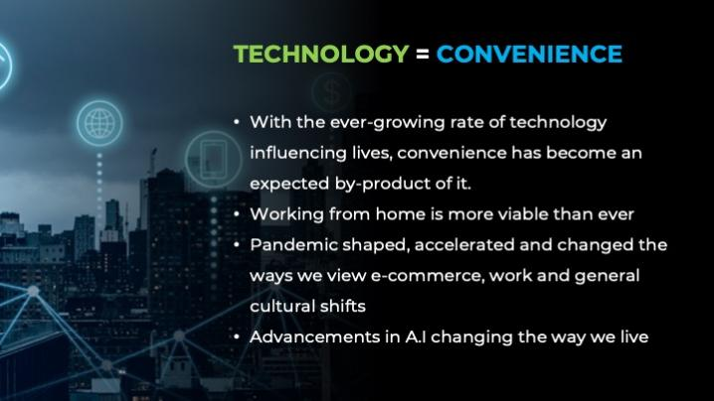
Taking a step back to Remote working, here we can see how the pandemic changed the way we worked overall, with an increase of people who work remotely even after the pandemic.  Technology has affected the way we interact with each other in person. With people spend more time indoors instead of socializing in the real world. | 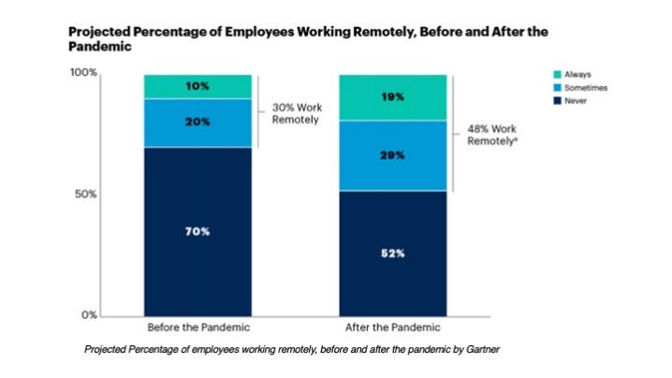
So to wrap things up. | 
Technology, has grown from being purely a convenience, to being almost a necessity in all our lives. | 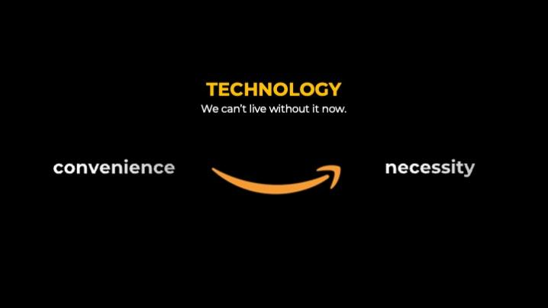
It’s indispensable for communication and accessing information. It improves our productivity and provides ease for necessities in daily living. | 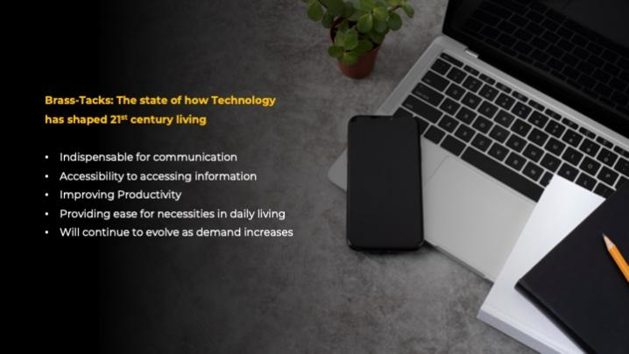
Technology will continue to evolve, just as our needs do as humans.  And With all these changes, the problems that already stem from technology today, will also evolve tomorrow.  It is up to us to be responsible with how we use it.  And that it is it from me. I’ve been Ivan, thank you for listening. | 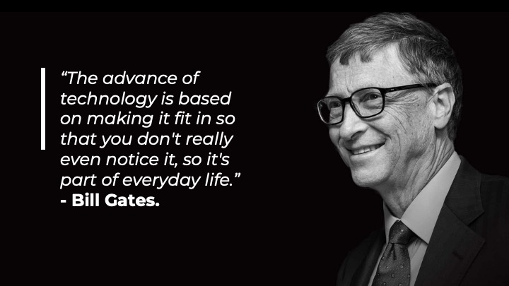

LEGEND: - blue text ( Optional to read if there is still time )
- Blue background boxes ( Can be skipped over )

